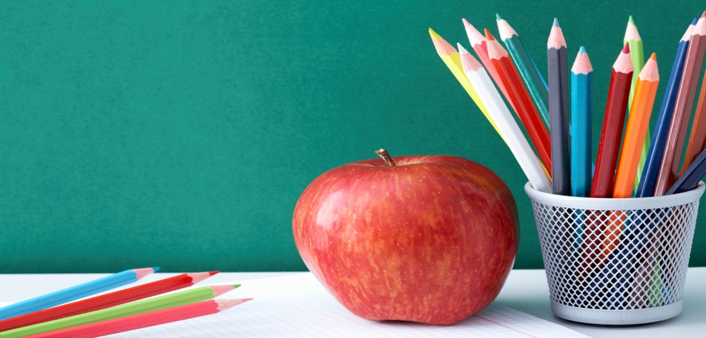Gibbs Elementary

Blended Preschool

Supply list

(for class use)

1~ refill bag of Baby wipes for class use

1~pack of Crayola Markers

1~24 count of Crayola Crayons

1~ pack of colored pencils

1~ Dry Erase Markers

Clorox wipes

Every child will need…

(Label with your child’s Name)

\*A change of clothes for the season with socks

(Please place in gallon size baggie with name on it)

\*A full-size backpack.

(needs to be big enough to put their daily folder in unbent)

\*One reusable water bottle daily